

**General Sir John Kotelawala Defense University**

**Faculty of Computing**

**Department of Computer Science**

Group Project Undertaken in partial fulfillment of the requirement for the

BSc Information Technology/ Computer Science/ Computer Engineering/ Software Engineering Degree

**Intake 35**

**UNIVERSITY ELIGIBILITY CHECKING SYSTEM**

**Analysis Report**

|  |  |  |  |
| --- | --- | --- | --- |
|  | **Group Details** | | |
| **Group Number** | **Student Number** | | **Student Name** |
| 12 | D/CE/18/0005 | | ABTMAS Bandaranaike |
| D/CS/18/0009 | | DA Iddamalgoda |
| D/CS/18/0015 | | BLA Kalhari |
| D/CE/18/0018 | | IWMHD Bandara |
|  | **Project Details** | | |
| **Project Title** |  | University Eligibility Checking System | |
| **Supervisor** |  | Mrs. WPJ Premarathna | |
| **Co-Supervisor** |  |  | |

**CONTENT**

1. **Analyzing the Existing System**
   1. **Current System**
   2. **Strengths & Weaknesses of Current System.**
2. **Data Collection Methods**
   1. **Data Collection Plan**
   2. **Way of Collecting Information**
   3. **Why we use particular information Collecting method**
3. **Requirement Specification of new System**
   1. **Functional requirements**
   2. **Non-Functional Requirements**
   3. **Technical Requirements**
4. **UML Modules for new System**
   1. **Use case Diagram**
   2. **Class Diagram**
   3. **Sequence Diagram**
5. **Analyzing the existing System** 
   1. **Current System**

Our project is about developing a university eligibility system which is given a set of priority list of eligible degree programs according to each z-score of the applicants.

The current existing system of UGC is a bit complex and our main objective is to simplify that entire process. Currently they are providing an online registration form. The applicants have to refer the UGC Handbook and fill the form. However this is somehow complex for the applicants & being unqualified for the government universities. The UGC handbook is also available as a softcopy in the UGC website, but there is no difference whether the applicant refer it as a hardcopy or softcopy. The understanding part of each & every sentence of the

Book is required and the applicant have to go through the whole book. Since there is a huge competition for government universities it is very much required to fill the form correctly. Due to small misunderstandings the whole admission form will be rejected. And this may lead to the entire failure of his/her university life. So one of our objective is to simplify this process and providing a filtered details of each degree program stream wise. That is, if one applicant is from the Art stream & he/she do not need the details of the degrees for maths or science streams. He/she only needs to refer the art faculty degree programs details. So through our system we will filter this on his/her behalf.

As the next problem which is our main objective we will focus about the priority list of degree programs related to each z-score. In the existing system when the applicant enter his/her z-score and other required details, the current system provides list of degree programs but without filtering. That is, if one student has 3C passes and from maths stream, we are pretty sure that he won’t qualified for engineering degree program. But in the existing system it’ll provide engineering degree as an option for the degrees he have to select. So this is useless. By going through the whole handbook and when trying to fill the form by also referring to the instructions in the form the applicant will already confuse and sometimes give-up the whole process.

For the academic year of 2013, out of 55,241 candidates who applied for university admission, only 43.8% were able to gain access to the state universities through the UGC, despite satisfying minimum requirements for admission. So as usual the disqualified amount will be mainly due to the failures of registration process. So through our system we can enhance the registration process and it will be a great opportunity for the applicants. So through our system we are sure that we can wish our applicants a bright university life.

* 1. **Strengths & Weaknesses of Current System.**

**Strengths**

* Provide additional functionalities such as “Nanasala” for rural areas with low computer literacy.
* Increased access for foreign students into local universities.
* High commitment of UGC and University management to enhance quality and relevance of academic programs, research and development and innovation output.
* Guaranteed State funds for higher education.

**Weaknesses**

* Slow adaptation, acceptance and preparedness to use emerging technologies.
* Relatively low efficiency and productivity compared to the potential.
* Some outdated and inappropriate rules and regulations increase the complexity of the entire registration process.
* Inadequacies of institutional capacities in providing opportunities updating of knowledge and skills of work force.

1. **Data Collection Methods**
   1. **Data Collection Plan**

We are mainly focusing on UGC existing system. Therefore for further requirements we decide to contact UGC. Hence as we need to simplify the overall registration process we need to have statistics about the students who are qualified for universities in each year according to their z-scores.

All the statistical reports can be obtain from UGC.

* 1. **Way of Collecting Information**

As our data gathering methods we used 2 sources.

1. Interview
2. Questionnaire

We interviewed the secretary of University Admission Department of UGC, for further clarifications. In here we are mainly discussed about the failures of existing system that we are observed. After providing a brief explanation about our project scope they are agreed to give us the statistical data.

Next we create a Questionnaire with the aid of Google form and distributed it in our social media groups, for the sake of ideas of the majority. And to make sure that they are also having the same idea that we have about the failures of the existing system.

Following are the answers & the questions of the questionnaire & suggestions provided by the participants in the process.

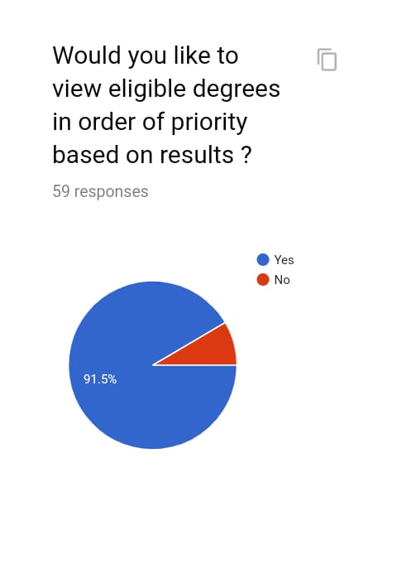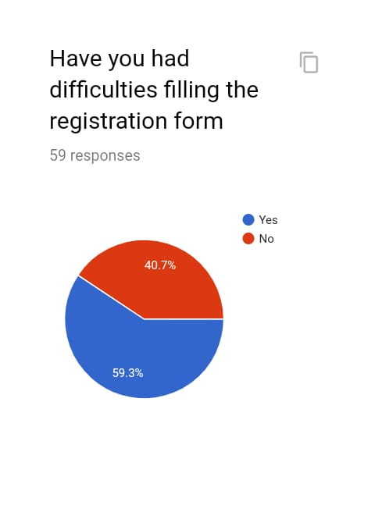

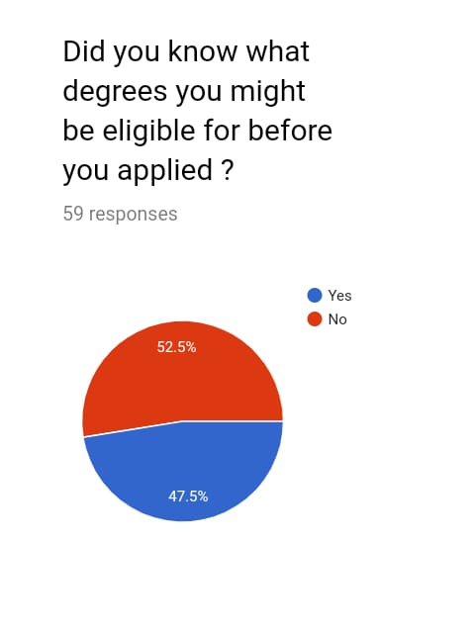



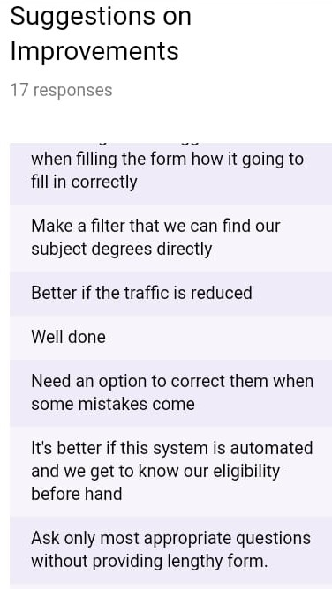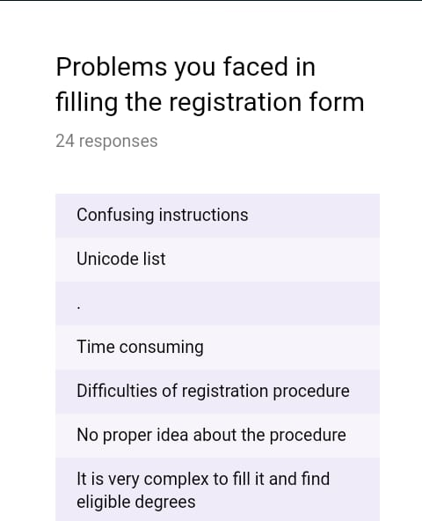

* 1. **Why we use particular information Collecting method**

We need to find the ideas about the existing system of UGC. So the best way to search for that is conducting a Questionnaire. As with the technology most of the people have their own smart phone and also in social medias. So we used this as a benefit and create an online google form and distributed among our friends, chats groups.

Then we choose interview as our next data gathering method is because rather than getting data from website or someone relatable outside, after visiting them we can get a clear idea about the existing system and what they really want to improve in the system.

1. **Requirement Specification of new System**
   1. **Functional requirements**

* Output degree(s) most probable to be selected into.

Provide a filtered priority list of eligible degree programs that he/she can apply depending on their z-score. This may increase the efficiency of the existing registration procedure. Then the candidate need not to be confuse about their selection because through our system we provide the most applicable degree for their z-score as the first option. Candidates can apply for the universities without any issue on their behalf. This may also increase the usability of the system.

* Filtered degree contents according to each z-score.

If we consider about a candidate in Art stream he/she didn’t need any details about the degree contents in maths/bio/tech/commerce fields. Therefore through our proposed system we will provide a filtered degree content in stream wise. This also may increase the system efficiency. The process of referring the book sentence by sentence will be simplified.

* Background research about statistical data of No.of candidates selected for universities in each year.

Since most of the times candidates who are willing to apply for universities has no basic idea about the university selection. That is they have no proper knowledge about how to apply for the most probable degree they can achieve. Through our system we will do a background research and provide a detailed information about how the selections are made relevant to each z-score, district & also how the priorities are given.

* 1. **Non-Functional Requirements**
* User friendly Interface

Will provide instructions which are not difficult to learn & understand.

* Security & privacy

Ensure security and privacy are built in to design and development processes and that web-based systems are fit for purpose from the outset.

* Flexible technology
  1. **Technical Requirements**

Mainly our aim is to create a dedicated web application for the system. The web application will be mainly based on the languages HTML, PHP and CSS. We will be coding all the web pages in the web application using these three languages.

The database connection will be done by using SQLite & there will be a database created for three different categories.

The graphics will be created using Photoshop. And then the will be brought into the web pages in order to combine with the three languages.

The basic part of the web application will be coded using HTML and CSS languages. But the database connection part will be done by using the PHP language. And also we suppose to use Android Studio to create the android.

1. **UML Modules for new System**
   1. **Use case Diagram**

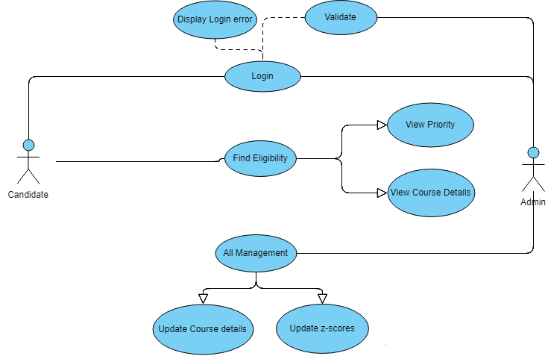

* 1. **Class Diagram**

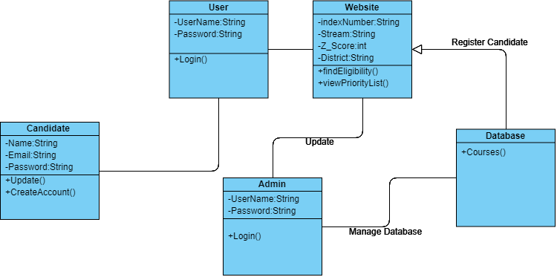

* 1. **Sequence Diagram**

